ME 460

HW #7

Leviticus Rhoden

8.17)

8.23)

8.25)

9.12)

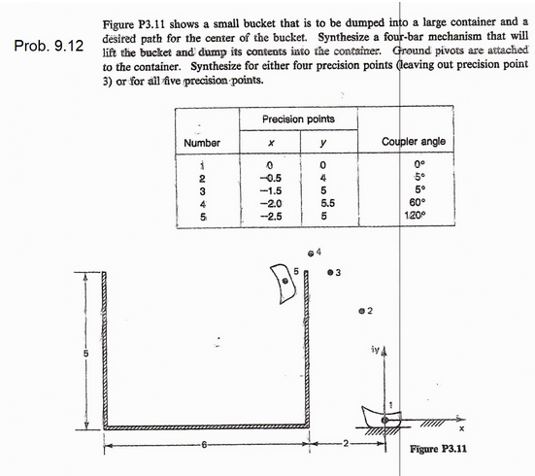

HW3-Prob.3)